**System Description:-**

* A **Library Management System** wants to create a database to store details of its libraries, books, and borrowers.
* The library is a place where so many people look for different kinds of books available in the library and want to issue it for some limited period of time.
* The library provides a peaceful and silent environment to the book lovers to read their favorite books.
* To maintain the record of the books, a library information system helps to achieve that purpose.
* LMS can have following characteristics:
  + For borrowing the item from the library, any user must get registered in the system initially.
  + Easy search for a book by its name, author name or publisher name in the online library.
  + Users need not go to the library to Issue any kind of book; one can do renewal of the book online.
  + If a book is not available at a particular moment then one can reserve it for the future.
  + The moment the book or magazine or CD is checked out by the borrower, the reservation is canceled. The reservation is also canceled through an explicit cancellation procedure.
  + If the user somehow forgets to return the book before the due date, then the user pays fine. Or if the user forgets to renew the book till the due date, then the book will be overdue and the user pays fine.
  + Avoid the manual work of issue and return process of book.
  + Maintenance of book and other things like(news papers, magazines, CD-DVD)
  + Librarians have a key role in this system. The librarian can easily create, update, and delete information about titles, borrowers, items and reservations in the system.
  + Updating databases is the important role of Librarian.

**There are some service goals which a library should provide, such as:**

A. The Reader (Library members) or book receiver's information like id, name, address, contact_no, etc.

B. The book information like author_name, price, publisher name, No of copy etc.

C. Employee information.

D. Registration of all issued books and returned book details.

To achieve these above described goals, library management information system (MIS).

**Major components or Subsystem of library MIS:-**

1) Books detail management

2) Library Member, Reader or issuer details management

3) Transaction inventory management

4) Registration detail

5) Future development planning and forecasting

**Explanation of major components or sub system of library management system:-**

**(1) Book detailed management:-**

* Book detail module stores information in the database.
* For different **types of book, publisher name, year of publication, ISBN number** etc.
* Each and every book has been given a unique **identification number** for the book. To identify that book uniquely.
* It is easy to search book by book title, author or publisher.
* Book information module generates MIS reports of book detail which is used by various levels of MIS to take decisions.

**(2) Library member or issuer detail management:-**

* This module is used in library mana to store information of library members as well as readers.
* The following information of library members are managed in a database such as the unique **id of the library member, name, address, time limit given to the member, book detailed issue by that member**.
* This information will help to generate a MIS report for which book is issued by which library member on a specific date.
* Unique id will retrieve member information easily so that the change of ambiguity is less.

**(3) Transaction management:-**

* Transaction module performs different transactions of the library such as **book issue, return and penalty management**.
* Transaction module uses data from the student **information module** and **book information module**.
* It keeps track of which book is issued by which library member for how many days.
* It also maintains details of returning books by the issuer.
* According to the return date, if generate the penalty detailed report.

**(4) Book Inventory management:-**

* In the library many books are there to arrange them; the books are organized in a cupboard.
* If there is a big amount of books it requires inventory management.
* Inventory management is used to manage book detail in various aspects such as, authorize book detail, subject wise book detailed etc.
* If the same user demands for specific book in the library then order for that book is generated and purchased by management.

**(5) Registration detail:-**

* Registration area is useful to keep track of both the book and issuer.
* The system contains information such as: Book id, Book name, Issuer id, Issuer name, Issuer Date, Return Date, and Limit of Date.
* Using this system, we can come to know which customer is having which book on which date the book is issued and the last date of returning the book .
* If the customer return the book after his/her time limit, how much is the penalty of each book per day.

**(6) Future development planning:-**

* This system may suggest which new things should be included in the library to satisfy the customers.
* It can include more departments like engineering books, general knowledge books, stories and poems sessions etc.
* This system may suggest yearly membership for regular readers.
* It may also take donations of books by people.

**Various Library Information System Levels:-**

This MIS can be used at various levels:-

**(I) Operational level:-**

* Registration area enables operational level to maintain records of daily book issues and returning transactions.
* Keep track of book information and book issuer systems also belong to this level.

**(ii) Management level:-**

* Inventory area belongs to the management level to make the decision of ordering more books for the library.

**(iii) Strategic level:-**

* Future development planning system enables the strategic level to make decisions after some years which changes should be done or which department should be included in the future.

**MIS Diagram of Library Management System**

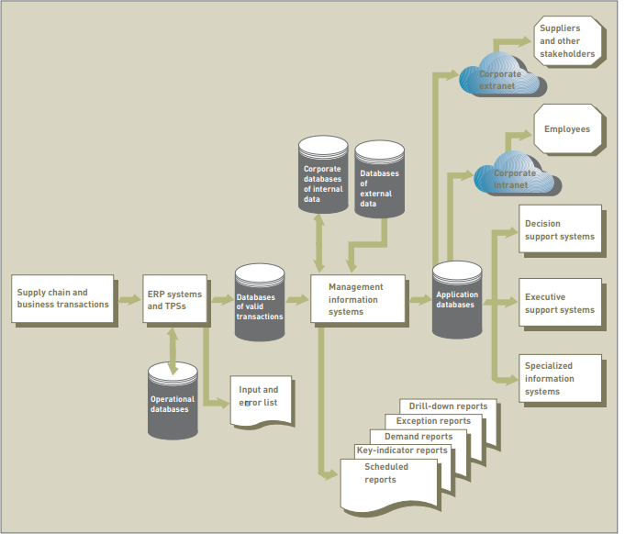

**Various kinds of reports generated by library management system :-**

**1. Scheduled Reports:-**

* Daily book-issued status report
* Book return report
* Daily student attendance report

**Daily book issued status report:-**

| **Book-id** | **Student_id** | **Issue_date** | **No_of_days** |
| --- | --- | --- | --- |
| B0001 | s0001 | 22/02/2023 | 7 |
| B0002 | s0002 | 24/02/2023 | 7 |
| B0003 | s0007 | 24/02/2023 | 5 |

**Book return reports:-**

| **Book_id** | **Student_id** | **Return_date** | **Penalty_amount** |
| --- | --- | --- | --- |
| B0001 | S0001 | 28/02/2023 |  |
| B0002 | S0002 | 02/03/2023 |  |

**2. Key - indicator reports:-**

**Penalty details reports :-**

| **Book_id** | **Student_id** | **Issue_date** | **Return_date** | **Penalty_amount** |
| --- | --- | --- | --- | --- |
| B0002 | S0002 | 01/05/2023 | 15/05/2023 | 15 |
| B0001 | S0001 | 22/01/2023 | 02/02/2023 | 10 |
| B0007 | S0005 | 14/01/2023 | 14/02/2023 | 30 |

**3. Demand Reports:-**

* Demanded book detail reports
* Book availability status report

**Demand book detail report :-**

| **Student_id** | **Book_name** | **Author_name** | **Demand_date** |
| --- | --- | --- | --- |
| S0003 | Java | Amish D. Vyas | 15/02/2018 |
| S0004 | VB.NET | Nikita B. Jarivala | 20/02/2018 |
| S0010 | IS | Stair | 25/02/2018 |

**Book availability status reports :-**

| **Book_id** | **Book_name** | **Author_name** | **No_of_available_book** |
| --- | --- | --- | --- |
| B0001 | Java | Amish D. Vyas | 1 |
| B0002 | VB.NET | Nikita B. Jarivala | 2 |
| B0003 | IS | Stair | 5 |

**4. Exception Report:-**

- Total stock of book report

- Author wise same subject book detail report

**Total stock of book reports:-**

| **Book_id,** | **Book_name** | **Author_name,** | **No_of_available_book** |
| --- | --- | --- | --- |
| B0001 | Java | Amish D. Vyas | 50 |
| B0004 | SE | R. G. Pressman | 45 |
| B0002 | VB.NET | Nikita B. Jarivala | 70 |
| B0003 | IS | Stair | 35 |

**Authorwise same subject book detail reports:-**

| **Author_id** | **Author_name** | **Book_name** |
| --- | --- | --- |
| A0001 | Nikita B. Jarivala | VB.NET |
| A0002 | Shyam Chavda | VB.NET |
| A0003 | C. Murthy | IS |
| A0001 | Stair | IS |

**5. Drill Down Report :-**

- Authorwise Bookwise issued book detail report

- Publicationwise subjectwise book detail report

**Authorwise Bookwise Issued Book detail report:-**

| **Student_id** | **S_name** | **Author_id** | **Book_name** |
| --- | --- | --- | --- |
| S0001 | Hetal | A0001 | VB.NET |
| S0002 | Shreya | A0002 | VB.NET |
| S0003 | Krishna | A0003 | IS |

**Publication wise subject wise book detail report :-**

| **Book_id** | **Publication_id** | **B_name** | **Publication_name** | **Subject** |
| --- | --- | --- | --- | --- |
| B0001 | P0001 | Java | Navneet | Java |
| B0007 | P0002 | Java | Bharat Chawada | Java |
| B0002 | P0003 | Basic of .NET | Nirav Prakashan | VB.NET |
| B0008 | P0004 | .NET programming | Benison | VB.NET |